Nonjabulo Mathenjwa

ST10077892

INSY6112

TEST

08 May 2025

Question 1

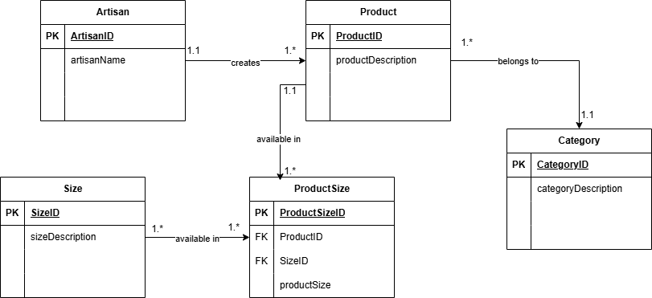

Question 2

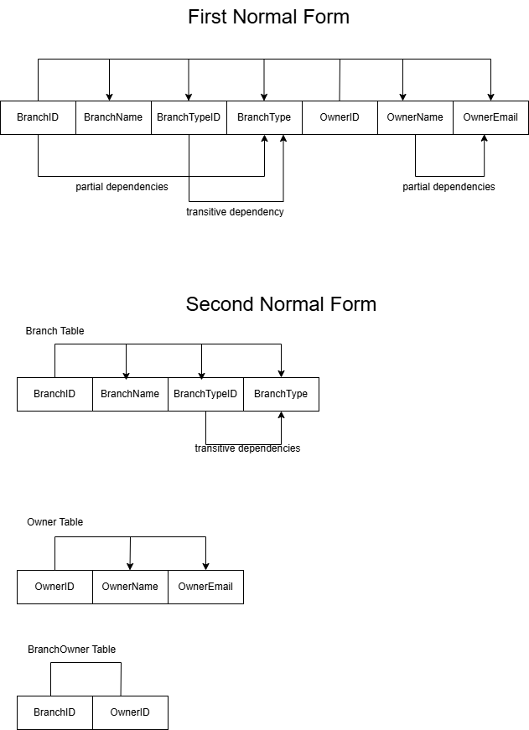

* For first normal form the repeating groups were already eliminated for me, all I had to do was point out the transitive and partial dependencies.
* Then for second normal form i removed the partial dependencies then separated the tables and their dependencies.